SAP Product Costing Overview

421100,263

Overview

•Product Costing is the tool used in SAP for planning costs and establishing material prices. It helps in estimating the Cost of goods sold manufactured and COGS of each for each product unit.

•SAP provides two different types of material costing process viz Material cost estimate with quantity structure and Material cost estimate without quantity structure.

•Material cost estimate with quantity structure works in combination of BOM (Bill of Material) and Routing assigned to it.

Integration

•Product Costing is integrated closely to various SAP modules as origin of data comes from below SAP module:-

* Material Management (MM) module for material master record / purchase info record.
* Production Planning (PP) module for Bill of material (BOM), routing and work center.
* Cost Center Accounting (CO) module as information of cost centers, its linkage of work center, activity types and activity wise cost centers help in determining conversion costs associated with manufacturing process.

•Results from Product Costing can also provide useful information for various SAP modules :-

* Material Management (MM) module for material and stock valuation.
* Sales and Distribution (SD) module
* Cost object controlling for calculating variances and WIP

Master Data

[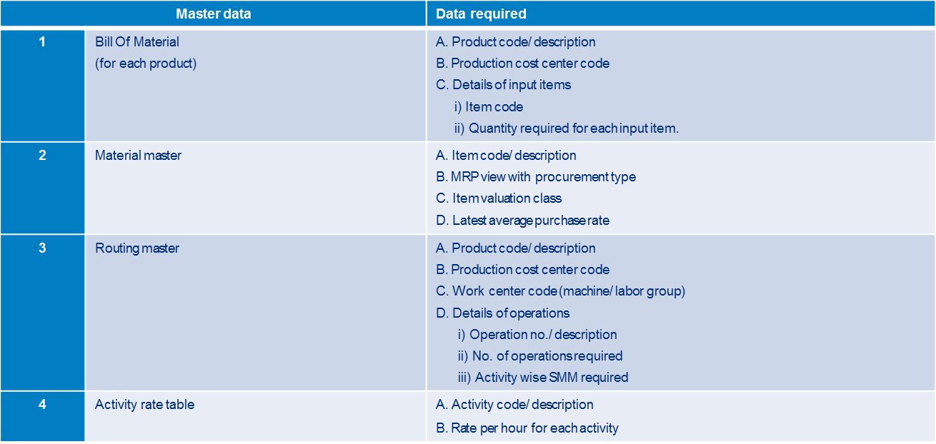](https://blogs.sap.com/wp-content/uploads/2014/01/picture1_366092.png)

Configuration

•Define Cost Component Structure (OKTZ)

[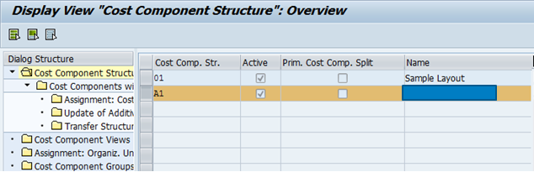](https://blogs.sap.com/wp-content/uploads/2014/01/picture3_366094.png)

[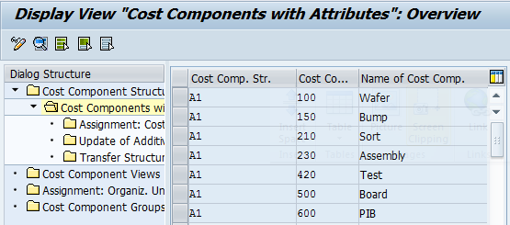](https://blogs.sap.com/wp-content/uploads/2014/01/picture5_366095.png)

•For each of cost component we assign a CE or a group of CE so that costs can be posted and rolled up to get the product cost.

[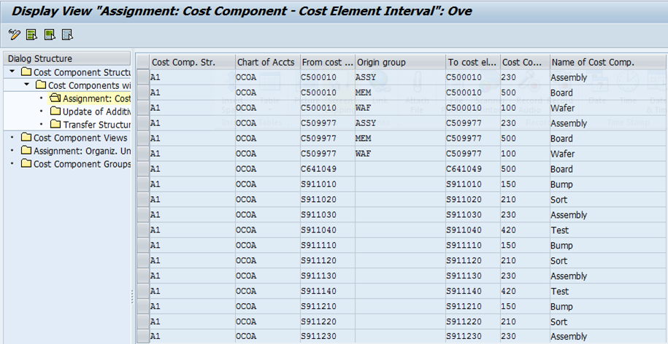](https://blogs.sap.com/wp-content/uploads/2014/01/picture6_366096.png)

•Costing Variant configuration (OKKN) – costing type defines the purpose of costing and updation of material prices. Standard cost update will be for legal inventory valuation and it will update standard price in material master.

[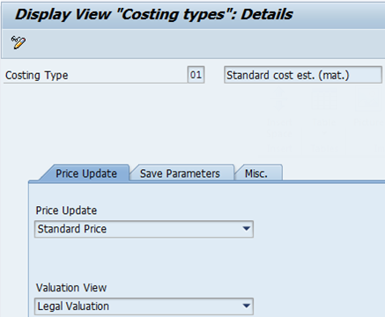](https://blogs.sap.com/wp-content/uploads/2014/01/picture7_366097.png)

•Costing Variant configuration (OKKN) – Valuation variant determines the strategy sequence to valuate materials.

[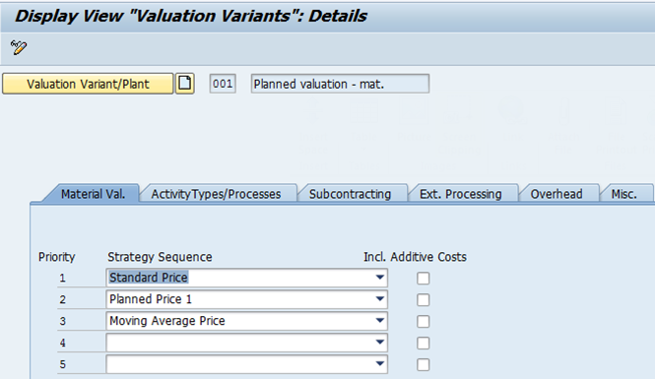](https://blogs.sap.com/wp-content/uploads/2014/01/picture8_366101.png)

•Costing Variant configuration (OKKN) – using date control we can set default values for the validity of the cost estimate, the qty structure and valuation date

[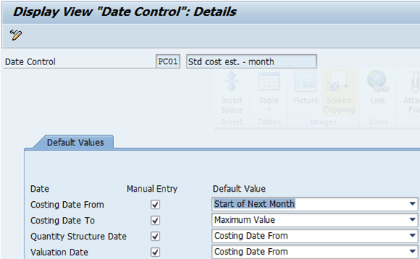](https://blogs.sap.com/wp-content/uploads/2014/01/picture9_366102.png)

•Costing Variant configuration (OKKN) – transfer control is used in transferring the existing cost estimate while costing a finished good, generally when multi level cost structure exists and costing is already done for one level.

[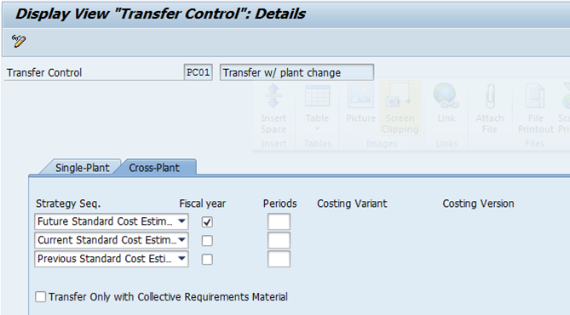](https://blogs.sap.com/wp-content/uploads/2014/01/picture10_366103.png)

Costing Run (CK40n)

•Material selection– here we define the materials that need to be costed in a plant.

•BOM explosion – this step involves exploding of material BOM after you have selected the material.

•Costing – in this step the actual costing of materials happen, system creates the qty structure automatically (BOM/routings) as per the quantity structure control defined in the costing variant.

•Analysis – in this step, results of costing run is analyzed and cost estimate is saved.

•Marking – after costing analysis, this step updates the result in the material master as future standard price.

  Release – updates the cost estimate in material master as current standard price, the stock value of material is changed and the new standard price for valuating material movements is active